Abjad Writing system

What is Abjad Writing system
# Source: Chatgpt (GPT-4-turbo) at [7/21/2025]
An abjad writing system is a type of writing system in which only consonants are represented with symbols, and vowels are either omitted or optional. Readers rely on context or additional vowel markings (called diacritics) to supply the correct vowels when reading.

What is mean of only consonants are represented with symbols
# Source: Chatgpt (GPT-4-turbo) at [7/21/2025]
The phrase "only consonants are represented with symbols, and vowels are either omitted or optional" describes the key feature of an abjad writing system.

🧾 Meaning Explained:
# Source: Chatgpt (GPT-4-turbo) at [7/21/2025]
In an abjad:
- Consonants have full letters or symbols.
- Vowels (like a, e, i, o, u) are not written most of the time.
- Vowels may be shown using small marks (diacritics), but these are usually optional and often left out in everyday writing.

✅ Example: Arabic (an abjad)
# Source: Chatgpt (GPT-4-turbo) at [7/21/2025]
Word: كتاب
- Pronounced: kitāb ("book")
- Written letters: k-t-b (ك ت ب)
- Vowels ("i" and "ā") are not written using separate letters.
- They can be added with diacritics, like this: كِتَاب (with vowel marks).

✅ Example: Hebrew (another abjad)
# Source: Chatgpt (GPT-4-turbo) at [7/21/2025]
Word: שלום
- Pronounced: shalom ("peace/hello")
- Written letters: sh-l-m (ש ל ו מ)
- Vowel sounds are inferred from context or learned knowledge.

💬 Why Do Abjads Omit Vowels?
# Source: Chatgpt (GPT-4-turbo) at [7/21/2025]
- In Semitic languages like Arabic and Hebrew, the meaning of words is mostly carried by consonants.
- Native readers can often guess the vowels from the pattern and context.
- Writing becomes faster and shorter, using fewer symbols.

📚 Summary:
# Source: Chatgpt (GPT-4-turbo) at [7/21/2025]
A writing system where only consonants are written and vowels are optional or shown with marks is called an abjad. This system is efficient for certain languages but can be challenging for learners.

🔤 Key Features of Abjad Writing Systems:
# Source: Chatgpt (GPT-4-turbo) at [7/21/2025]
- Consonant-Based
  - Each symbol represents a consonant sound.
  - Vowel sounds are typically not written, or are added using small marks.
- Diacritics for Vowels (Optional)
  - Short vowels can be shown using diacritic marks, especially in religious texts, poetry, or for learners.
  - Example in Arabic:
    - كِتَاب (kitāb, meaning "book") – uses diacritics for the vowels.
- Direction of Writing
  - Most abjad systems are written right to left.

📝 Examples of Abjad Writing Systems:
# Source: Chatgpt (GPT-4-turbo) at [7/21/2025]
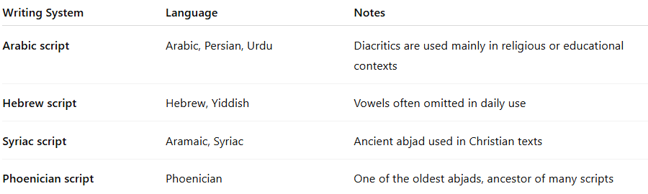

Writing System | Language | Notes
Arabic script | Arabic, Persian, Urdu | Diacritics are used mainly in religious or educational contexts
Hebrew script | Hebrew, Yiddish | Vowels often omitted in daily use
Syriac script | Aramaic, Syriac | Ancient abjad used in Christian texts
Phoenician script | Phoenician | One of the oldest abjads, ancestor of many scripts

✅ Advantages:
# Source: Chatgpt (GPT-4-turbo) at [7/21/2025]
- Efficient for native speakers who can easily infer vowels from context.
- Uses fewer characters, making it easier to write.
- Works well for Semitic languages, where word roots are typically built from consonants.

⚠️ Limitations:
# Source: Chatgpt (GPT-4-turbo) at [7/21/2025]
- Harder for beginners or non-native readers, since they must guess or learn the missing vowel sounds.
- Less suitable for languages where vowels are more important to meaning.

Abjad vs. Alphabet:
# Source: Chatgpt (GPT-4-turbo) at [7/21/2025]
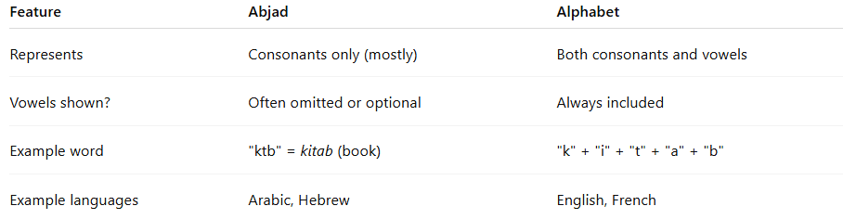
Feature | Abjad | Alphabet
Represents | Consonants only (mostly) | Both consonants and vowels
Vowels shown? | Often omitted or optional | Always included
Example word | "ktb" = kitab (book) | "k" + "i" + "t" + "a" + "b"
Example languages | Arabic, Hebrew | English, French

Is Arabic and Hebrew are Abjad or Alphabet or both
# Source: Chatgpt (GPT-4-turbo) at [7/21/2025]
Arabic and Hebrew are both primarily abjad writing systems, not full alphabets.

✅ Why They Are Abjads:
# Source: Chatgpt (GPT-4-turbo) at [7/21/2025]
- Only Consonants Are Written (Mostly)
  - In everyday writing, consonants are written using standard letters.
  - Short vowels (like "a", "i", "u") are usually not written and must be inferred from context.
- Optional Vowel Marks (Diacritics)
  - Arabic uses harakat (e.g., َ ِ ُ ) and
  - Hebrew uses niqqud (e.g., ְ ִ ּ )
These marks indicate vowels but are not used in regular writing, only in:
  - Religious texts (e.g., the Quran or Torah)
  - Language learning
  - Poetry or formal writing

🧠 But Can They Function Like Alphabets?
# Source: Chatgpt (GPT-4-turbo) at [7/21/2025]
- Yes, sometimes.
In modern Hebrew, matres lectionis (consonants like א, ו, י) are often used to indicate vowels more clearly, which gives it alphabet-like features.
- Arabic also uses long vowels (ا, و, ي), but short vowels are still usually left out.

📌 Conclusion:
# Source: Chatgpt (GPT-4-turbo) at [7/21/2025]
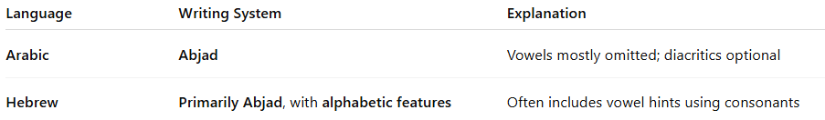

Language | Writing System | Explanation
Arabic | Abjad | Vowels mostly omitted; diacritics optional
Hebrew | Primarily Abjad, with alphabetic features | Often includes vowel hints using consonants

So, Arabic and Hebrew are both abjads, though Hebrew leans slightly toward an alphabetic system in modern use.

Summary:
# Source: Chatgpt (GPT-4-turbo) at [7/21/2025]
An abjad writing system is a consonant-based script where vowels are not fully written or are shown optionally with marks. It’s efficient and compact, especially for languages like Arabic and Hebrew, but can be challenging for learners.

